**Name: ____________________________**

**The second line of defence**

An infection occurs when pathogens make it past the first line of defence and enter the body. When this happens, the immune system responds in some general ways that treat all pathogens equally. For example, it can trigger an increase in core body temperature to produce a fever. This can help fight a range of different pathogens by making it too hot for them to survive.

Such general responses to infection make up the second line of defence.

1. What is the role of the second line of defence?
   1. To attack specific pathogens inside the body
   2. To prevent pathogens from entering the body
   3. To respond in a general way to any pathogens that have entered the body
   4. To remember pathogens so they can be quickly defeated in the future

We’re going to focus on three general responses that are part of the second line of defence – fever, inflammation, blood clotting and phagocytes.

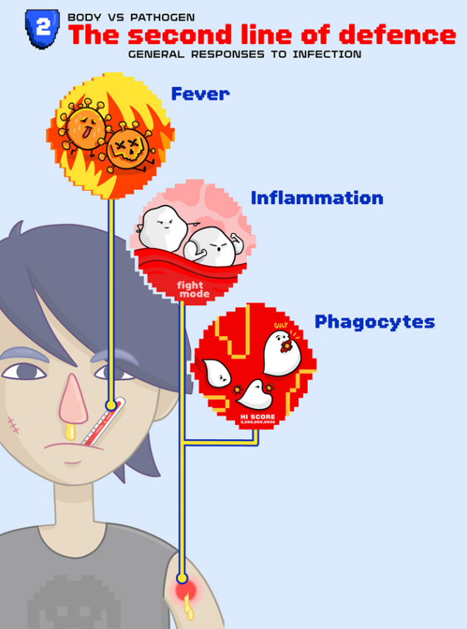**Fever -** Fever is an increase in core body temperature above 38°C. It is usually accompanied by shivering and sweating. A high temperature slows down or even kills some pathogens. It also speeds up processes that help the immune system deal with the threat.

**Inflammation -** Painful redness and swelling around the site of infection is called inflammation. It happens because more of the blood is directed to that part of the body. Blood contains white blood cells that are specialised to fight off pathogens which stops further infection from taking place.

**Blood clotting -** If microorganisms get into the body through a cut in the skin, the most important thing to do is close the wound quickly so that no more microorganisms can enter.

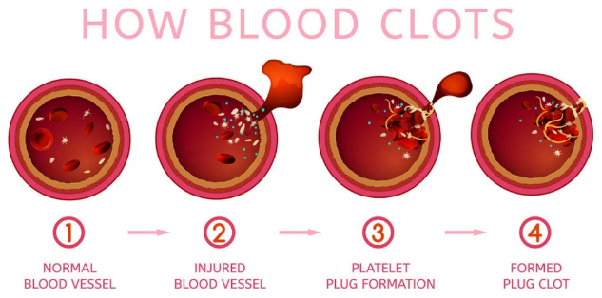

A scab formed through the process of blood clotting does just that. The blood contains tiny structures called platelets, and a protein called fibrin. A scab is basically platelets stuck in a fibrin mesh.

**Phagocytes -** Some white blood cells destroy anything that they don’t recognise as part of the body. They do this by “swallowing” or engulfing it. These blood cells are called phagocytes. Phagocytes help to protect the body by engulfing and destroying pathogens.

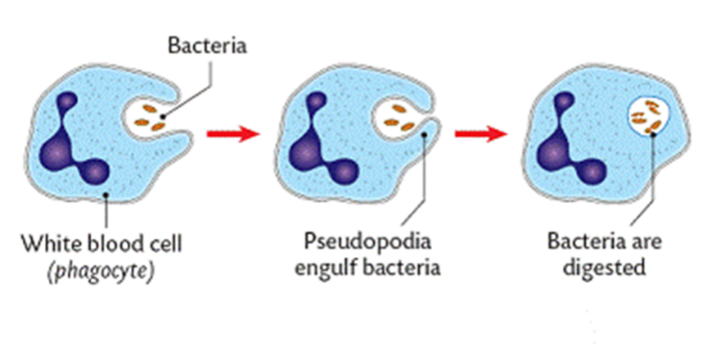

Having engulfed a pathogen, the phagocytes may also send out chemical messages that help nearby lymphocytes (other types of white blood cells) to identify the type of antibody needed to neutralise them. These lymphocytes launch the third line of defence.

1. True or False? An increase in body temperature above 38°C is a sign that the body may be fighting an infection.

True False

1. Match each feature of the second line of defence to its definition.

Fever Inflammation Phagocyte Blood clotting

|  |  |
| --- | --- |
| Feature | Definition |
|  | A type of white blood cell that destroys pathogens |
|  | Increased core body temperature that slows or kills pathogens |
|  | Platelets stick together in a fibrin mesh that close up open wounds |
|  | Painful redness or swelling around the site of infection |

1. Explain how the second line of defence relies on the heart pumping blood around the body.

**_____________________________________________________________________________________________________________________________________________________________________________________________________________________________________________________________________________________________________________________________________________________________________________**

**_________________________________________________________________________**

**_________________________________________________________________________**

1. Using the diagram below to help you, describe how phagocytes in the second line of defence protects the body.

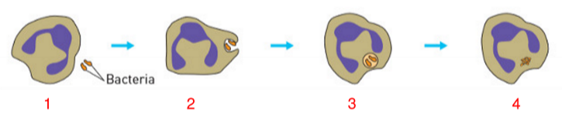

**_____________________________________________________________________________________________________________________________________________________________________________________________________________________________________________________________________________________________________________________________________________________________________________**

**_________________________________________________________________________**

**__________________________________________________________________________________________________________________________________________________**

**_________________________________________________________________________**

1. You cut your finger while camping and don't have a first aid kit. The cut becomes infected with harmful bacteria. Describe the three ways in which your second line of defence could respond to the infection.

|  |  |
| --- | --- |
| **Response** | **Description** |
|  |  |
|  |  |
|  |  |

**How am I feeling about this topic?**

|  |  |  |
| --- | --- | --- |
|  |  |  |
| *I get it!* | *I kinda get it.* | *I don’t get it.* |